
Cell Imaging: Team Contract

Names:
John Ahn, Demetrius Schank, Jonathan Kim
DATE CREATED: August 26, 2025
DATE SIGNED (students): September 2, 2025

Contact information

Student Name | Student Email | Other Contact Info
John Ahn | Jahn02@villanova.edu | 267-671-8251
Demetrius Schank | Dschan02@villanova.edu | 215-570-2294, demetrius.schank@gmail.com
Jonathan Kim | Jkim176@villanova.edu | 646-244-4289

Advisor Name: Dr. Rosalind Wynne
Advisor Email: rosalind.wynne@villanova.edu

Meeting Information
The locations are in order of priority. If one location is not available, the team will notify the rest of the team in the MS Teams chat and head to the next location.

Locations (in order of priority):
- Innovations Lab in Drosdick Hall
- Drosdick 031
- Falvey Library first floor
- Discussed on the fly
Times:
- Tuesday, 1:00-2:15pm
- Thursday, 1:00-2:15pm
- Third time optional meeting time (look at team guidelines).

Problem Space
The Cell Imaging Senior Capstone group’s main objective is to characterize cells based on size and shape, continuing from the previous year’s project of analyzing cell velocity through capillaries. Identifying size and shape can help recognize health concerns, such as sickle cell disease in red blood cells, that occurs when cells are sized and shaped differently than under normal/healthy conditions. This topic may be subject to change according to the amount of image and video data available to analyze online. The application of AI is still an interest for one or more members of the team.

Solution Summary
Images are processed through MATLAB in four distinct stages. In the first stage, the images are downloaded into MATLAB. In the second stage, all edges in the image are detected, although at this point it is not yet known whether each highlighted region represents a cell or the surrounding environment. In the third stage, cells are isolated from the background by applying a filter based on roundness, allowing borders to be removed and individual cells to be identified. In the final stage, the identified cells are recolored and overlayed onto the original image for visualization. Solution Summary can be subject to change (with approval and advice from Dr. Wynne) due to further research in MATLAB, AI, or machine learning/deep learning.

Gantt Chart
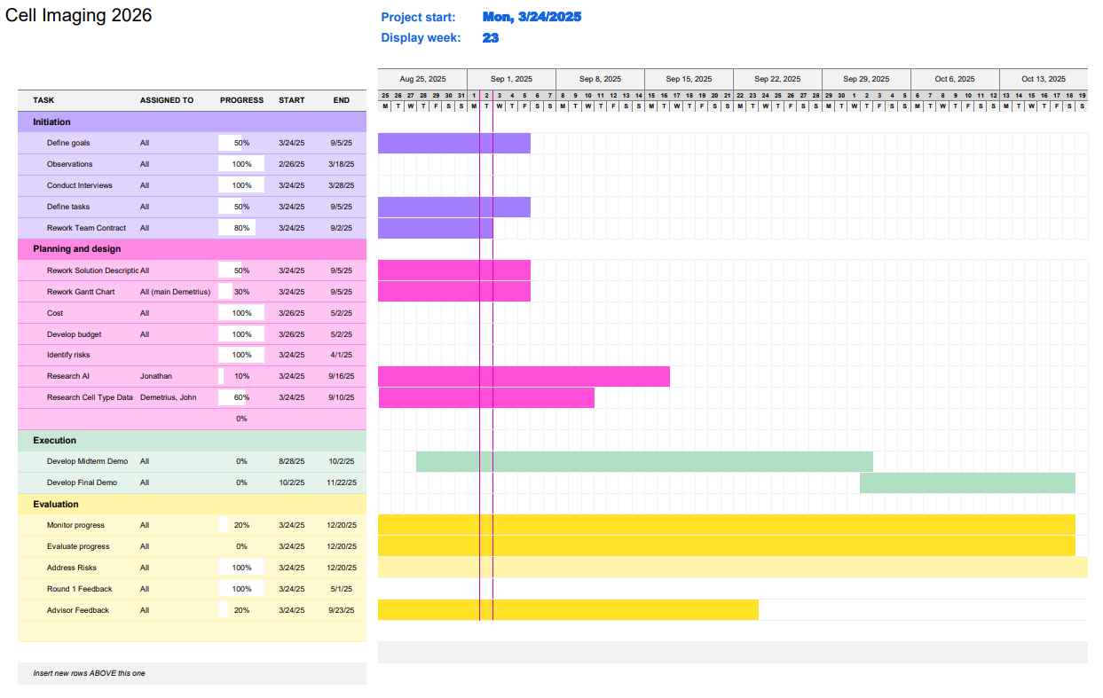
Gantt Chart will be updated with TSP reports (at minimum).

Team Guidelines
- Mandatory Meeting Expectations:
- Come prepared with laptops and other required technical devices.
  - Failure to do so will be noted on the timesheet task description. May lead to a more serious intervention meeting with either Dr. Klein or Dr. Wynne if this is a consistent issue.
- If you cannot make it to the meeting in-person, you are expected to let the group know ahead of time (30 minutes minimum) to give proper time to set up a virtual meeting. Members will be expected to attend virtual meetings unless a valid reason/excuse is given to the other members.
  - Failure to give group members proper notice about leave will be noted. On the third failure to notify members in a timely manner (30 minutes prior to meeting), Dr. Klein and Dr. Wynne will be advised about the members’ absence.
  - The group majority has the right to deem an ‘excuse’ valid or invalid for missing a mandatory group meeting time. Example: Missing a meeting to cram for an exam will likely NOT be a valid excuse, excluding the possibility of extenuating circumstances.
  - Work missed due to a valid excuse is expected to be made up on the member’s personal time. They are expected to make up at least half of the time they missed from a mandatory meeting to ensure the group is kept on track.
    - If they miss a 75-minute work session, they are expected to make up ~37 minutes of work time on their own, give or take 5 minutes. Does not need to be exact, just needs to be an effort.
    - Failure to report this on the timesheet may be held responsible against that user.
- Come with at least 1 topic of interest/goal for each meeting.
- Each member alone is responsible for logging their hours. Failure to do say may affect CAT performance review, as the logged hours are the only official record to see how much time/effort each team member has contributed to that week.
- Communication Expectations
  - All official communication will go through teams. That includes: any official reminders, absence notices, impromptu work times, messages regarding the project, etc.
    - iMessage group chat may be used as an alternative means of communication but will NOT count towards a member's official communication (ie. Letting members know of an absence only on iMessage may count as invalid communication according to the rest of the group’s discretion).
  - Members are expected to react or reply to a message in teams chat within 24 hours, especially if a member is @’d in a message.
    - Failure to reply in 24 hours will be noted on CAT performance reviews. Members will send another message ping to the user asking for the unresponsive user’s reply. Members must reply within 12 hours of that second ping.
    - Failure to reply to the second ping within 12 hours will severely affect CAT performance reviews and will be noted to Dr. Klein and/or Dr. Wynne.
  - Grace periods during weekends (including extended holiday weekends) may be granted regarding appropriate response times (excluding nested bullets below). Grace periods may be taken away if the privilege is abused.
    - Grace periods are not valid if it causes any late assignments/deliverables.
- Outside/Non-Mandatory Meeting Expectations:
  - This when2meet will dictate the time an optional third meeting will be scheduled. If a third meeting time is required, we will try to meet during these times.
    - The group will decide which time to work if it is decided that a third meeting is needed.
    - 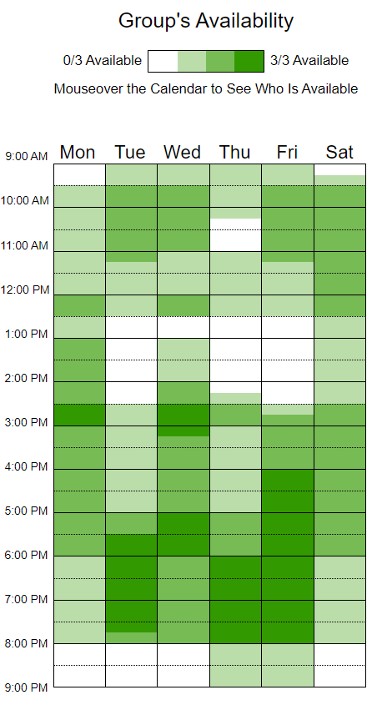
    - Third Workday Meeting Times are in dark green above.
    - When2meet link here
- Advisor Regulations/Expectations
  - Advisory meetings will be weekly. All members are expected to attend excluding excused extenuating circumstances.
    - Excused notice for missing meeting is 2 hours before meeting time. If you are expecting to miss a meeting, give team members a short report (bullet points will suffice) of their work progress/goals. Failure to do so given an excused absence will be noted on TPS and may affect group CATME scores.
    - 2 Hour window excludes unexpected illness.
  - Advisor Meetings will occur Weekly, Thursdays from 1:00pm-2:00pm
    - Location: Drosdick 010; Wynne Lab. Alternate locations may be needed.
  - Advisor meetings are expected to be at least 30 minutes in duration.
  - All times that work for the team:
    - Monday 2:30-3:00pm
    - Tuesday 1:00-2:15pm (designated class work time)
    - Tuesday 5:30-7:30pm
    - Wednesday 2:30-3:00pm
    - Wednesday 5:00-6:00pm
    - Thursday 1:00-2:15pm (designated class work time)
  - Some form of written feedback from advisor Dr. Wynne will be required at least bi-weekly after the first advisor meeting of the semester (likely week of 9/1/2025).
    - This is to ensure that both the group has substantial deliverables and that the advisor is engaged in the project.
    - Failure to receive written feedback before a reminder email is sent by a team member will result in a reminder email being sent by a team member.
    - Failure to have any form or written feedback after a warning message will be reported to Dr. Klein.
  - Advisors are required to send over any documents or project folders held by previous teams upon request.
  - The primary mode of communication between Team Members and advisor will be Villanova Outlook Email.
    - All communications must CC all team members.
  - The primary mode of getting documents signed will be through DocuSign unless free software limitations occur.
    - Alternative will be an in-person wet signature, document will be scanned in.

- Conflict Management
  - If there is a conflict (communication or absence), first an attempt will be made to notify the person of that issue. If problems start to occur again after the first instance, then an email/notice will be sent to Dr. Klein.
  - Conflict resolution will first be attempted to be resolved internally. If the group is unable to resolve the conflict, Dr. Wynne and/or Dr. Klein will be contacted.
    - If a conflict is not first attempted to be resolved internally and is instead immediately brought to Dr. Wynne or Dr. Klein, this may affect a particular member’s CATME evaluations, as they have failed to properly communicate with other team members. This excludes times when a member as already attempted to resolve their concerns with the group and feels the group’s solution is not satisfactory.
  - Members hold the right to have one-on-one meetings with Dr. Wynne and/or Dr. Klein to discuss general team concerns (not pertaining to a conflict with a specific team member). This includes but is not limited to concerns:
    - Overall team work ethic
    - Team effort imbalances
    - Overall teamwork performance
    - Overall Teamwork progress
    - Advisor work relationships
    - Quality of work assurance
  - Any team member holds the right to have one-on-one meetings with Dr. Wynne and/or Dr. Klein regarding their mental headspace regarding the project without requirement to notify the rest of the team, although a notice will be appreciated.
- Documentation and Conventions
  - Update the timesheet regularly. Be as honest and accurate as possible. A entry should not be made more than 4 days after the original work time—any entry after the 4-day window will not be valid and will be considered falsifying your time.
    - Falsifying your time sheet will be handled as a serious conflict and will follow the conflict resolution steps above.
    - Timesheet can be found on the timesheet page in the Cell imaging tab or Class Notebook.
  - Put all active documents and research in the designated teams shared folder. Create and organize the documents as needed. Name all documents appropriately, including assignment number and assignment title.
  - Each person is responsible for writing with proper tone, description, and grammar. For most assignments, grammar doesn’t need to be perfect, however we must maintain high levels of description for any assignment/task note we do.
  - Each document must be formatted as each template is given. DO NOT start a blank document and add titles unless you are aware of how to use MS Word Styles to match the template given for an assignment.
    - All templates must be downloaded, uploaded to the teams files channel, and renamed appropriately.
  - If any member feels that their descriptions or writing assignments are not satisfactory, they reserve the right to advise the user to go back and make changes.
    - If the user fails to make significant, effective changes, this may be cause for proper escalation according to our conflict management guides.
    - Other members in the team are NOT responsible to correct ones writings. If any member wants assistance, they must ask for it (from peers or advisors) or attend the Villanova Writing Center.
  - Notes about advisor meetings will be noted by John Ahn on the Advisor meetings note page in the ECE 2026 Cohort Class Notebook.
- CATMEs
  - It is up to each team member individually to complete the CATMEs as accurately as possible.
- Roles
  - Roles are subject to change/modify, but the team will have clearly defined roles by the midterm.
  - All members are responsible for research and data collection.
  - Demetrius Schank
    - Cell Imaging Team Leader
    - Monitors and encourages team progress
    - Designated group submitter
      - Unless otherwise verbalized
    - Manages Gantt Chart
    - Main lead on TPS reports
  - John Ahn
    - CATME reminder
    - Primary note taker for advisor meetings
      - Be as descriptive as possible
    - Help manage Gantt chart

  - Jonathan Kim
    - Technical Advisor

Signatures
By signing this contract, you agree to the conditions listed in the above sections. You will put forth your best effort to achieve the goals of your senior design project and work as a cohesive team with your peers. Include your advisor. You may e-sign or sign on paper, but you cannot just type your name.

Signature:

John A, 08/28/2025

Signature:

Jonathan K, 08/28/2025

Signature:

Demetrius Schank, 08/28/2025

Signature:

Name, date:

